# Assignment 6 Microwave Remote Sensing

## Question 1 Land cover

### Make a landcover map

* Import “MODIS_IGBPLandCoverClass” raster data into QGIS.
* Open “Google Satelite” with Openlayer plugins.
* Resymbolize the data and assign different labels with classification.
* Make a new composer.

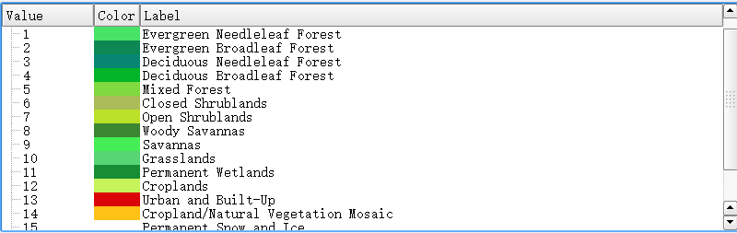

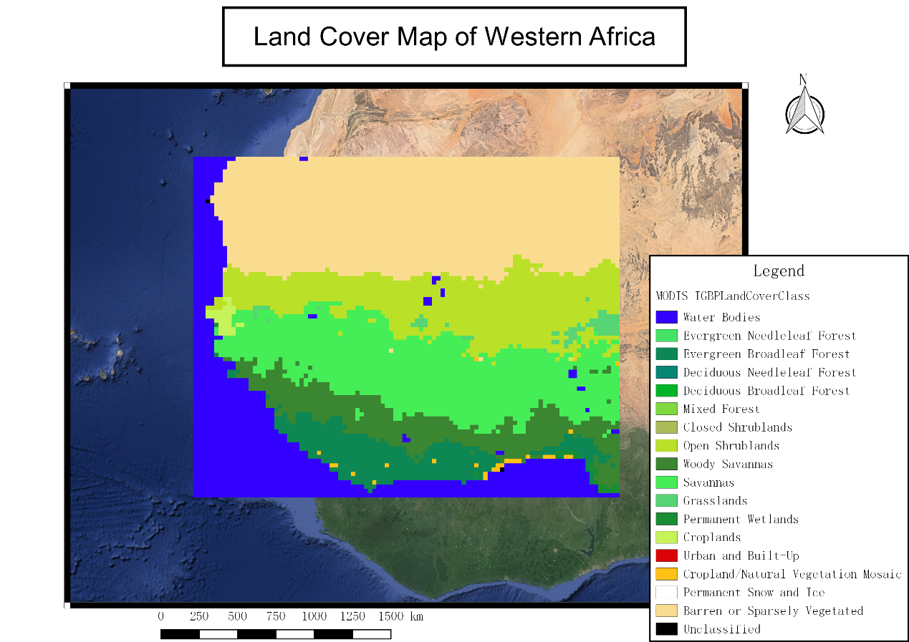

### What is the major land cover classes in West Africa?

The classes cover major west Africa are barren or sparsely vegetated area, open scrublands, savannas area, woody savannas area and evergreen broadleaf forest area.

We could somewhat observe the trend of varying from dense forest area in the southern part to barren area in the northern part.

## Question 2. TRMM Precipitation

### Make a map of the total precipitation in 2009

* Import monthly mean precipitation data into QGIS.
* In raster calculator, type “("TRMM3B43_WA02@1" +"TRMM3B43_WA01@1" +"TRMM3B43_WA03@1"+"TRMM3B43_WA04@1"+"TRMM3B43_WA05@1"+"TRMM3B43_WA06@1"+"TRMM3B43_WA07@1"+"TRMM3B43_WA08@1"+"TRMM3B43_WA09@1"+"TRMM3B43_WA10@1"+"TRMM3B43_WA11@1"+"TRMM3B43_WA12@1")/12*24*365” in the shell.
* Resymbolize the raster data to make a better visualization.
* Make a new composer.

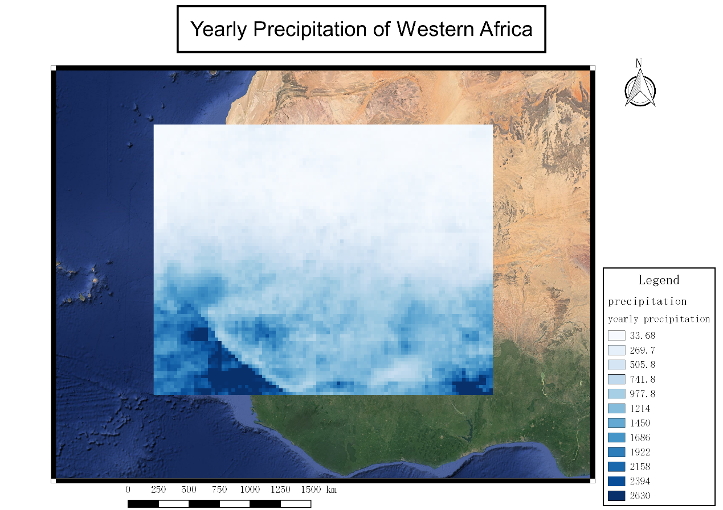

### What is the mean total precipitation in each of the land cover types?

* Convert landcover raster data into vector with polygonize.

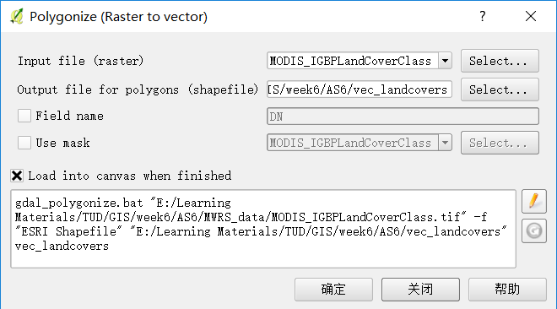

* Dissolve the vector data so that all features add up together with the same classifications.

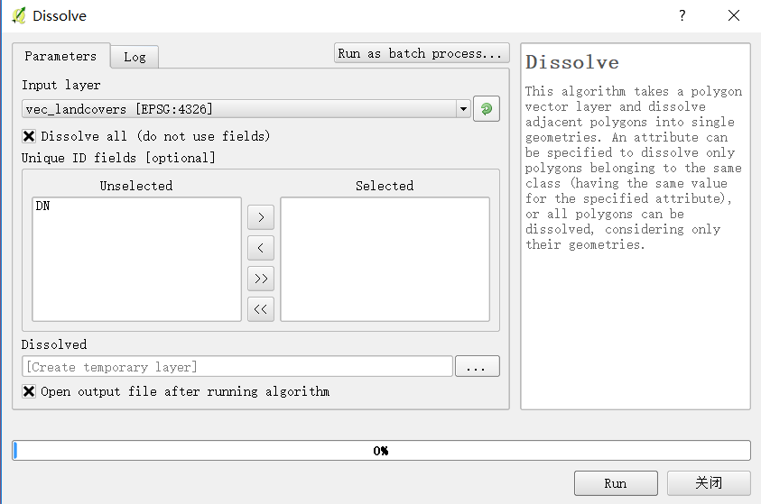

* Calculate “count” and “sum” with zonal statistics by assigning converted vector data as a mask.

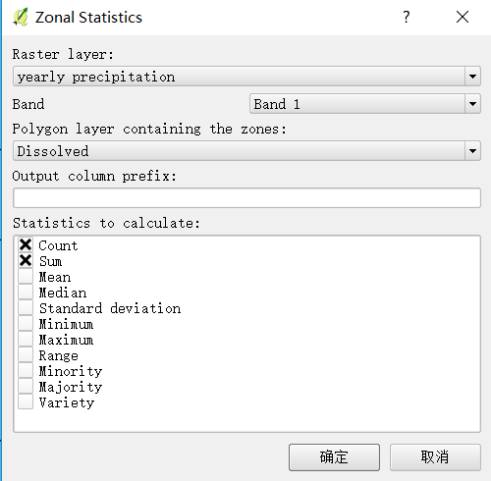

* Inside attribute table, calculate mean precipitation as “sum” divide by “count” in field calculator. By the way, we could achieve this only by taking “mean” into account.

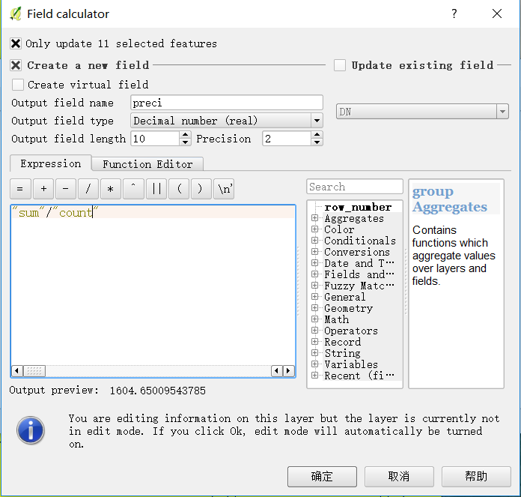

The results of precipitation in different land cover types are shown below.

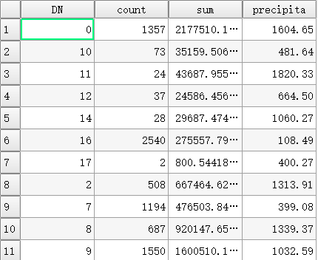

### Make a new shapefile, and add at least 5 points in North-South transect so that you have points in each of the major land cover classes.

* Create a new shapefile, and add a point in vertical transection based on the vector “count” value in a descending order.

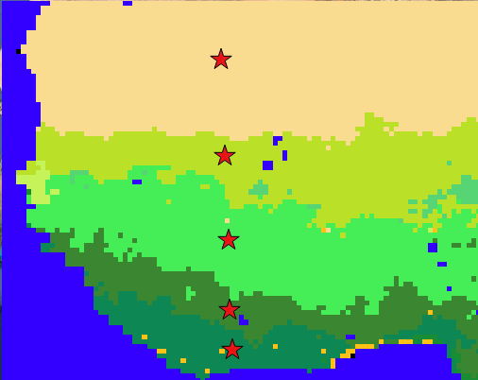 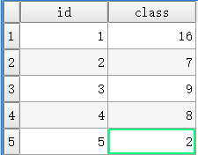

Class field shows the original order of class in the previous raster data.

### Extract a time series of the monthly values of precipitation rate for each point.

* To get a time series of precipitation at these points, “point sampling tools” is used to assign values with 12 monthly mean precipitation data.

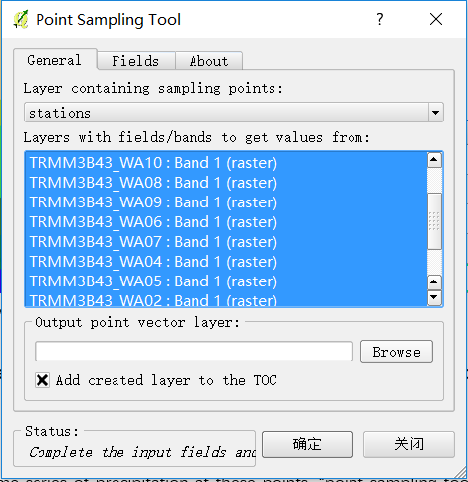

* Export time series data of precipitations at these points to excel, and plot the trend.

|  |  |  |  |  |  |  |  |  |  |  |  |  |
| --- | --- | --- | --- | --- | --- | --- | --- | --- | --- | --- | --- | --- |
| point | 1 | 2 | 3 | 4 | 5 | 6 | 7 | 8 | 9 | 10 | 11 | 12 |
| 1 | 0.0 | 0.0 | 52.6 | 0.0 | 1.7 | 7.2 | 2.6 | 0.0 | 67.3 | 0.0 | 1.1 | 2.7 |
| 2 | 0.0 | 1.6 | 3.2 | 2.7 | 8.9 | 18.5 | 97.7 | 114.6 | 78.8 | 9.6 | 2.5 | 0.0 |
| 3 | 0.5 | 4.8 | 10.0 | 12.2 | 77.6 | 147.1 | 132.1 | 196.0 | 227.1 | 138.1 | 8.9 | 0.5 |
| 4 | 0.0 | 84.4 | 76.3 | 139.8 | 51.9 | 42.7 | 78.6 | 123.4 | 142.8 | 79.2 | 47.7 | 1.9 |
| 5 | 16.4 | 94.3 | 214.8 | 139.1 | 134.1 | 158.8 | 67.9 | 40.6 | 65.5 | 59.9 | 151.8 | 30.0 |

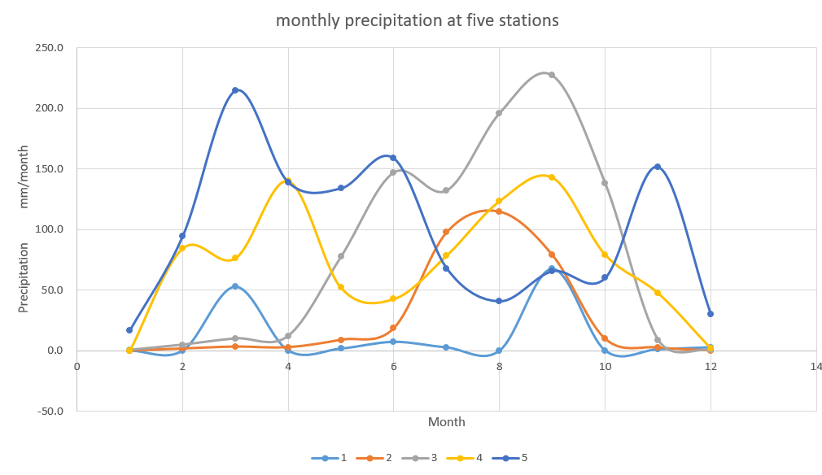

### What is the total annual precipitation at each point?

* Apply “point sampling tools ” again, and use yearly precipitation data as input raster data, then we get

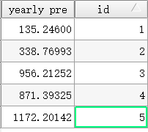

### Describe the variation of precipitation vary during the year at each point.

Station 1 is defined as bare soil or sparsely vegetated area where precipitation is relatively low. The maximum precipitation is around 50 mm/month and it occurs during the summer. Moving from north to south, precipitation at station 2 rises a bit and achieves around 120 mm/ month at its peak during summer as well. Going further south, station 4 and station 3 shows relatively larger rainfall and with analogy, the maximum value appears during the summer. Nevertheless, station 5 shows a different pattern. Even though it closes to the shoreline and the maximum value of precipitation is almost the same as the station 4, it somehow shows up around March.

### What influence does the West Africa monsoon have on the seasonal distribution of precipitation at each of your sampling points? How does this vary from South to North?

During summer, the land surface temperature is higher than sea surface temperature, which results in the wind blowing from the Atlantic Ocean towards inland so that much more precipitation is observed landward while further decrease as the total volume is dissipated.

Reversely, during winter, sea surface temperature is higher than land, which causes wind blow seawards so that precipitation is accumulated seaward. As observed, station 5, located almost along the coast, gains much more precipitation in this period than other stations.

Because of the discrepancy, this actually results in different types of land cover from south to north. For instance, broadleaf forest requires the most amount of water to maintain its growth and almost uniformly distributed.

## Question 3. AMSR-E Soil Moisture

### Extract the time series of C-band soil moisture at each sampling point in your transection.

* Import “LPRM” monthly mean soil moisture data into QGIS.
* With “point sampling tools”, estimate monthly soil moisture series at each point.
* Export data into Excel and plot a graph.

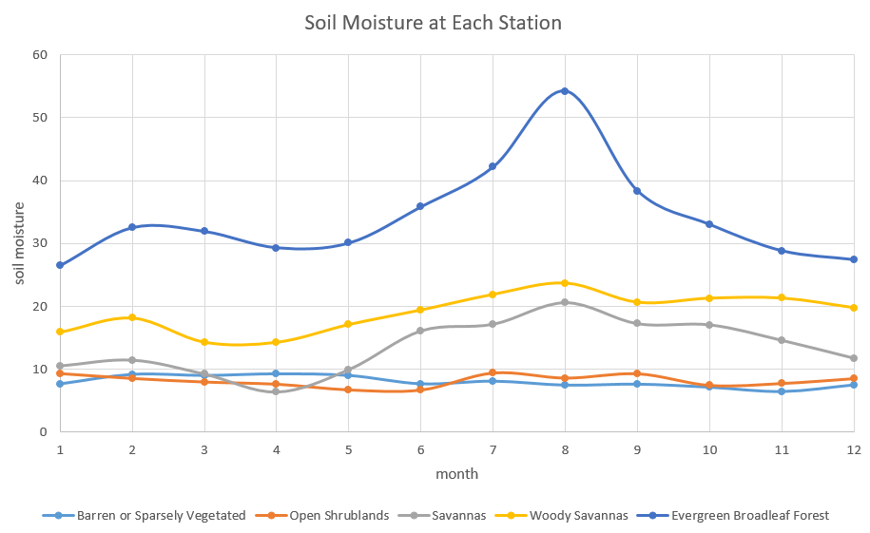

### In which land cover class is soil moisture highest/lowest?

Following the graph, soil moisture in the Evergreen Broadleaf Forest area reaches the highest value and the lowest in the Savannas area.

However, looking through all months may have unexpected randomness, by taking time averaging, yearly averaged soil moisture gives us the highest value in the Evergreen Broadleaf Forest area as well while the lowest in the Barren or Sparsely vegetated area.

### In which land cover is soil moisture most uniform during the year?

Basically, the soil moisture in the barren area and Open Shrubland area are uniformly distributed, which means low variation among the year.

This can be expected since in the barren region, little water can be stored. Once the rain falls down, it evaporates immediately.

### In which land cover does soil moisture have the strongest seasonal cycle?

In the Evergreen Broadleaf Forest area, it shows the strongest seasonal cycle as it hits the highest value during summer and drops to the lowest value during winter.

Station in the Woody Savannas area shows the same pattern but not as obvious as the Evergreen Broadleaf Forest area.

### Explain the variations observed in soil moisture in terms of the observed seasonal cycle precipitation.

|  |  |
| --- | --- |
|  |  |
| Correlation coefficient: -0.24 | Correlation coefficient: 0.48 |
|  |  |
| Correlation coefficient: 0.81 | Correlation coefficient: 0.12 |
|  | |
| Correlation coefficient: 0.09 | |

As in the discussion above, the bare soil can not store water inside, and hence it does not have variation monthly.

There is not much variation in terms of seasonal precipitation in Woody, Savannas and Open Shrublands area. The reason behind it is that these stations are quite close to the shoreline, which means the ground water table is relatively high, that to some extend, these soils are saturated during the year.

In the evergreen area, a negative relationship between soil moisture and precipitation exists. This can be explained as in Spring, a huge amount of water is absorbed by trees for their growth from the soil layer, and therefore, a slightly drop down is shown in the graph. To the contrary, less water consumption during summer so that the soil moisture rises.

## SMAP Soil Moisture

### List three advantages of using an L-band radiometer rather than a C-band radiometer for soil moisture monitoring.

* L-band is much more sensitive to the soil moisture due to better penetration in the agricultural region.

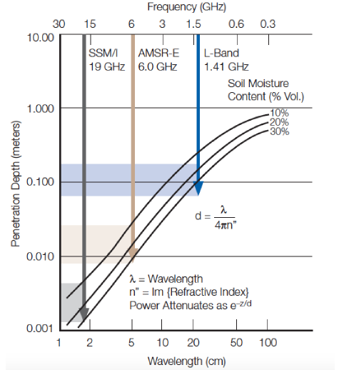

* Vegetation transmissivity to soil emission at L-band frequency is higher than C-band.

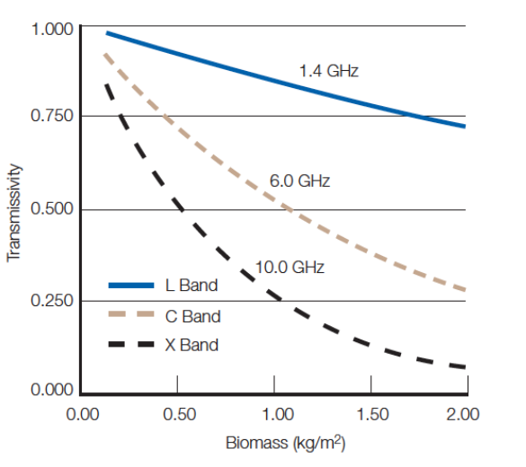

* L-band frequency gets more broad range of dielectric constant than C-band, which makes soil moisture more detectable.

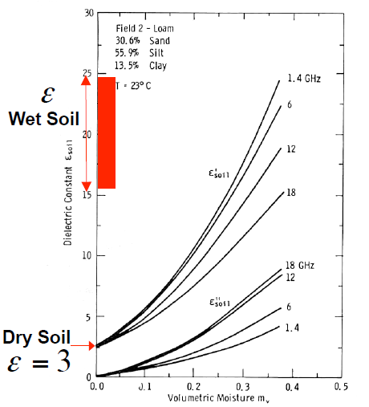

### There are SMAP overpasses at 6AM and 6PM. Give three reasons why only the 6AM observations are used to estimate soil moisture.

* At 6 am, the difference between soil and canopy temperature is minimum among a day.
* Reduce the observation errors produced by Faraday rotation in polarization process.
* Around 6 am, the evaporation and transpiration are relatively smaller than at 6 pm, which will reduce measured errors.